Enterovesicular Fistula (Crohn’s)
Stem: 31-year-old male presents with dysuria and pneumaturia for the last 3 weeks without other changes in his bowel habits.
PE: vital signs and physical exam are grossly normal.
PMH: Crohn’s Disease on Mesalamine (Pentasa).
PSH: None.
Labs:CBC, CMP with normal values. Urine analysis and urine cultures showed growth of enteric flora.
Any further information you want?!
- Colonoscopy:Less than 1 year ago, he thought it showed good control of his disease.
- CT scan Abdomen /pelvis?–What kind of contrast?Rectal / Oral (Consider no IV contrast to allow extravasation showing from bowel to bladder) – CT showed air in the bladder.
- MRI (MR Enterography) (best sensitivity for diagnosis):Fi stulous connection between dome of the bladder and distal small bowel visualized.
- Cystoscopy:E rythema in the dome of the bladder
- SBFT or barium enemas:(H ave a poor prediction for EV-fistulas)
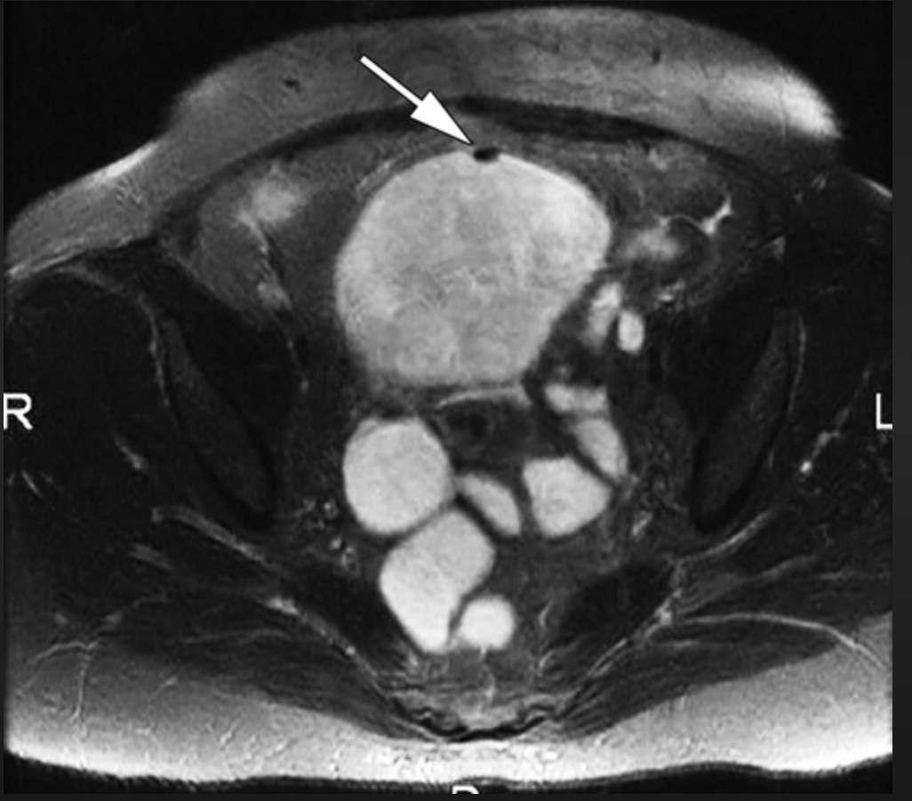
(MR Enterography picture, air in the bladder at fistula site)
Describe what options exist for medical management of Crohn’s and when they are indicated?
- 5-ASA compounds:I nduction agent, not very effective long term.
- Steroids:Induction agent for flairs, not to use long term.
- Thiopurines/MTX: Used for maintenance, not in acute flairs.
- Biologics: Infliximab (remicade)→adalimumab (humira)→other options. Used for moderate to severe diseases not responsive to other agents.
What would you like to do now?
- Treat UTI F irst –Augmentin vs cipro+flagy l.
- Step Upmanagement: continue mesalamine→glucocorticoids→i mmunomodulators→Biologics
- In this patient, steroids for induction+ antibiotics to treat possible infection is a reasonable first approach.
- If symptoms do not improve, consider Anti-TNF agent vs. surgery.
- If surgery is planned, hold off on immunomodulators until post-op period is over.
Scenario:Patient has persistent entero-vesical fistula despite treatment with Remicade. What now? Surgery
- Describe:
1. Can be done MIS or open
2. Place foley catheter
3. Resect fistulizing segment of small bowel with the fistula tract– do not have to do a large bladder resection.
4. Do a limited resection of just involved bowel.
5. Visualize ureters
6. C an inject methylene blue into catheter to visualize bladder defect
7. Repair bladder defect with absorbable suture, 2 layers
8. Leave Foley catheter for 1-2 weeks – can do a cystogram before pulling
Scenario 2:Now your patient is a 75-year-old male with no hx of IBD.H e presents with pneumaturia and fecaluria. What is your diagnosis and what do you do differently from before?
- Concern is for colovesical fistula: D iverticula r vsMalignancy.
- C olonoscopy:Doesn’t have one before
(Must obtain: Resident must do themselves and describe steps)
- cystoscopy to rule out cancer.
- CT: Sigmoid colon adherent to the bladder, diverticulosis, air in bladder. No abscess.
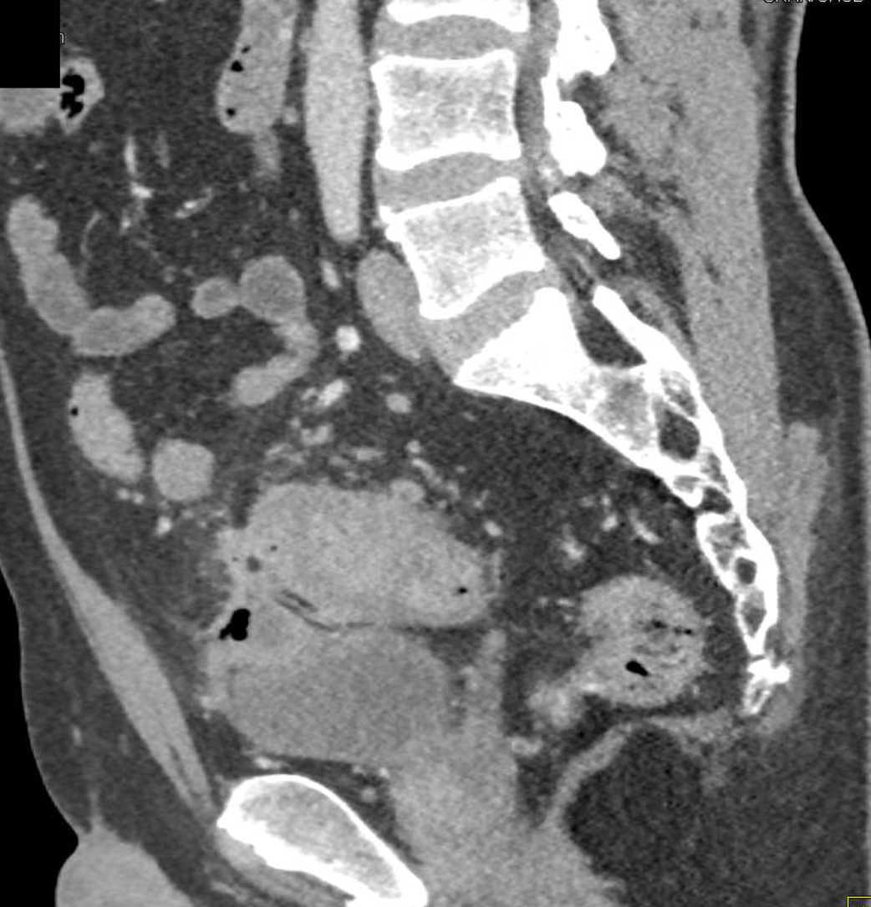

How do you treat?: S urgery
- Sigmoidectomy.
(Open / lap / Or Robotic … Lateral to medial or medial to lateral dissection)
- P atient in dorsal lithotomy
- M obilize the sigmoid colon along white line of Toldt or via medial to lateral approach score the peritoneum along the right side.
- I dentify the inferior mesenteric artery.
- I dentify left ureter.
- Take down the adhesions of the sigmoid colon to the bladder.
- Resect
- Anastomosis.
- Fill foley with sterile fluid and clamp, to distend the bladder and assess for urine leak: (Usually no leak and no need to repair)
- Leave foley in place for 1-2 weeks, can do cystogram before discon tinuing.

Pitfalls:
- Not Performing colonoscopy,themselves.
- Not knowing medical management of Crohn’s disease.

